MEIOSIS CONCEPT INVENTORY

Question 1 [select the best answer]

One of the characteristics that differentiates all haploid cells from all diploid cells is that

a) haploid cells have half as many chromosomes than diploid cells.
b) haploid cells have one full set of chromosomes while diploid cells have two.
c) haploid cells’ chromosomes have a different structure/shape from diploid cells’ chromosomes.
d) haploid cells have half the amount of DNA as diploid cells.

Expert answer: b

Alternatives/misconceptions²: a) i) The absolute number of chromosomes determines ploidy.
ii) Diploid cells always have more chromosomes than haploid ones, regardless of what species they come from; being haploid implies having fewer chromosomes.

c) i) Haploid cells’ chromosomes have an “I” shape/structure, diploid cells’ chromosomes have an “X” structure (confusion between replicated vs. unreplicated chromosomes and ploidy).

d) i) Total amount of DNA must be higher in 2n than in 1n cells.
ii) Unsure about what a “set of chromosomes” is, but convinced that the absolute amount of DNA or the number of chromosomes does not define ploidy.

Concept: ploidy
Bloom level: II
Difficulty index (proportion of students answering correctly): 0.37
Discrimination index (D)¹ (ranges from 0-1): 0.38
D.E.¹ (ranges from 0-1): 0.50
Common incorrect answers² a (31%)³

Question 2 [select the best answer]

A certain cell is diploid and has a total of six chromosomes. If we pretend that its chromosomes remain condensed throughout the cell cycle, which of the diagrams below correctly represents the chromosomes of this cell before DNA replication?

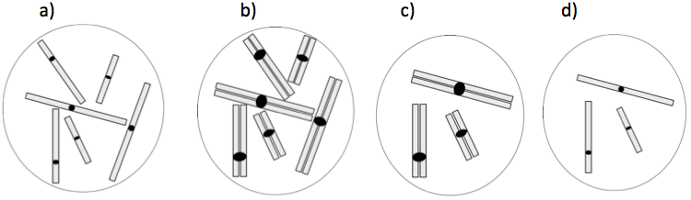

Expert answer: a

Alternatives/misconceptions: b) i) Diploid cells have “X” shaped chromosomes (and here we need something with 6 chromosomes).
ii) Did not pay attention to “before” DNA replication; chromosomes normally have an “X” structure (so b is better than a).

c) i) Confusion between homologous chromosomes and sister chromatids.
ii) A diploid cell before replication is like the cell in c), DNA replication causes three brand new chromosomes to come into being (if c) is before replication, b) would represent the same cell after replication).

d) i) If the diploid (2n) cell has six chromosomes, then n=3, so we are looking for a cell with three chromosomes (tendency to “solve for n”).
NOTE: some students choose d) in this case because they think it’s the only cell with three chromosomes, while others recognize that it has three unreplicated chromosomes.

Concept: ploidy, what “counts” as a chromosome.
Bloom level: III
Difficulty index²: 0.30
D²: 0.52
D.E.²: 0.87
Common incorrect answers² b (22%)³

Question 3 [select the best answer]

If we pretend that chromosomes remain condensed throughout the cell cycle, what notation best describes the cell pictured below?

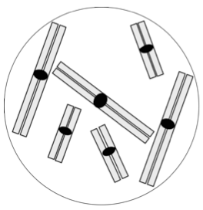
- n=2 (haploid with two chromosomes)

- n=3 (haploid with three chromosomes)

- 2n=6 (diploid with six chromosomes)

- 3n=6 (triploid with six chromosomes)

Expert answer: d

Alternatives/misconceptions: a) i) Confusion among ploidy (haploid, diploid), meaning of the number that n is equal to, and what a set of chromosomes is (i.e. interprets “n=2” or “haploid with two chromosomes” means that there are two sister chromatids in each chromosome).

b) i) Idea that if there are three chromosomes of each “shape”, the haploid number must be three (and no other option has “3”).

c) i) Cells where chromosomes are composed of two sister chromatids are diploid (and here there are six chromosomes, so the notation should include “=6”).

Concept: ploidy
Bloom level: III
Difficulty index²: 0.35
D: 0.75
D.E.²: 0.95
Common incorrect answers² c (34%)³

Question 4 [select all the answers that apply]

One or more of the cells represented below are haploid. Which one is it/which ones are they?

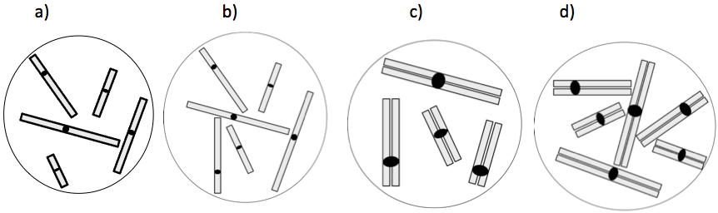

Expert answer: a+c

Alternatives/misconceptions: a) i) Cells with an odd number of chromosomes are always haploid, uncomfortable/unsure with all the others.
NOTE: if students don’t pay attention to the instructions (“check all that applies”), this is usually the answer they choose.

b) i) [RARE] Haploid cells can’t have chromosomes composed of two sister chromatids, and cells should not have odd numbers of chromosomes.

a+b) i) Haploid cells can’t have chromosomes composed of two sister chromatids.
ii) Confusion between sister chromatids and homologous chromosomes (if there are sister chromatids, then the cell must be diploid).

a+b+c) i) A cell is haploid if its chromosomes are not composed of sister chromatids, but also if there aren’t chromosome pairs. [As long as there are even numbers of each chromatid, the cell is diploid].

Concept: ploidy
Bloom level: III
Difficulty index²: 0.54
D: 0.77
D.E.²: 0.83
Common incorrect answers² a+b (23%)³

Question 5 [select all the answers that apply]

One or more of the cells represented below are diploid. Which one is it/which ones are they?

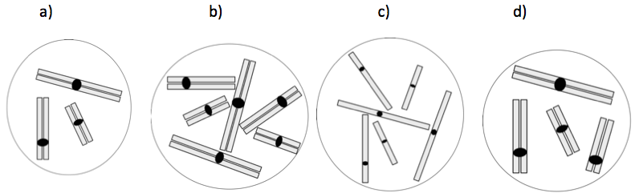

Expert answer: b+c

Alternatives/misconceptions: b) i) Diploid cells have pairs of homologous chromosomes (√), chromosomes always have an “X” structure.

c) i) Diploid cells have pairs of homologous chromosomes (√), but when chromosomes have sister chromatids “they don’t count” because otherwise “cells would always be diploid” [ploidy can only be determined when there are no sister chromatids].

b+d) i) A diploid cell is one where chromosomes are composed of sister chromatids, but it can’t have an odd number [of chromosomes].

a+b+d) i) A cell is diploid if its chromosomes are composed of sister chromatids.

b+c+d) As long as there are pairs of “matching chromatids”, the cell is diploid [“matching chromatids” can be two sister chromatids or two pre-replication homologous chromosomes; students refer to what I called “matching chromatids” as “matching chromosomes” in both cases].

Concept: ploidy
Bloom level: III
Difficulty index: 0.48
D: 0.81
D.E.: 0.84
Common incorrect answers² a+b+d (20%)³, b+c+d (13%)³, overall 41%³ of the answers included “d”.

Question 6 [select all the answers that apply]

A diploid plant of interest has a total of two chromosomes per (somatic) cell, and its genotype is AaBbDd. If we pretend that chromosomes remain condensed throughout the cell cycle, which of the diagrams below could represent a cell that contains the two chromosomes of this plant?

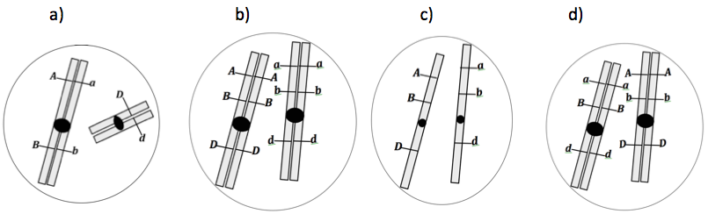

Expert answer: b+c+d

Alternatives/misconceptions: a) i) Diploid cells are those where chromosomes are composed of two sister chromatids, and A/a genotypes means that one chromatid must have the “A” allele and the other has the “a” allele.

b) i) A diploid cell has pairs of homologous chromosomes (√) and chromosomes must have an “X” structure (two sister chromatids). All dominant alleles should be on the same chromosome, and all recessive alleles should be on the same chromosome.

b+c) i) Diploid cells have pairs of homologous chromosomes (√). There can’t be a combination of dominant and recessive alleles on the same sister chromatid.

b+d) Chromosomes should be composed of two sister chromatids; chromosomes composed of sister chromatids are “better” and look “more right”.

c) i) Idea that two sister chromatids are two chromosomes (so all the other options represent four chromosomes, and we should look for one with two).

Concept: ploidy, relationship among chromosomes structure, alleles and genotypes (integration)
Bloom level: IV
Difficulty index²: 0.63
D: 0.73
D.E.²: 0.86
Common incorrect answers² b+d (25%)³

Question 7 [select all the answers that apply]

Sometimes chromosomes are represented like X’s or like in the picture on the right.
This picture represents a
a) chromosome composed of two sister chromatids.

b) chromosome that has undergone DNA replication.

c) chromosome in its diploid state.

d) pair of homologous chromosomes.

Expert answer: a+b

Alternatives/misconceptions: a) i) Understands the relationship between chromosomes and sister chromatids, but is unsure about how this relates to DNA replication.

b) i) Idea that the shape of the diagram indicates that the chromosome has replicated, and the two “bars attached together” are identical, but unsure whether it’s called a pair of homologs or two sister chromatids.

c) i) Idea that the two “attached bars” indicate that the chromosome is diploid, but unsure whether it’s called a pair of homologs.

a+c) i) A chromosome with two sister chromatids is a diploid chromosome.

a+b+c) i) Sister chromatids are the two “bars” that make up the “X” shape (√), which is a diploid chromosome. DNA replication results in the formation of a diploid chromosome (confusion about what “diploid” means)

a+c+d) i) Sister chromatids are the two “bars” that make up the “X” shape, which is a diploid chromosome as well as a pair of homologs.

Concept: representation of chromosomes, relationship between chromosome structure (sister chromatids or not) and DNA replication
Bloom level: II-III
Difficulty index²: 0.45
D: 0.90
D.E.²: 0.96
Common incorrect answers² none were very common, but 12%³ chose a+b+c, and 11% chose “a only” (note: compared to data collected in more recent deployments of parts of the inventory, this proportion of 11% is uncharacteristically low for our first year course).

Question 8 [select all the answers that apply]

In a eukaryotic cell, DNA replication results in an increase in the

- amount of DNA in that cell.
- number of chromosomes in that cell.
- number of DNA molecules in that cell.
- ploidy of that cell (e.g. from 2n to 4n).

Expert answer: a+c

Alternatives/misconceptions: a) i) Replication makes more DNA, so as soon as it starts there is an
increase in the amount of DNA in the cell. Unsure about the rest.

b) [Alone or in combination] DNA replication duplicates chromosomes by creating a new chromosome for each already existing one.

a+b) i) DNA replication duplicates chromosomes by creating a new chromosome for each already existing one. Since chromosomes are made of DNA, the amount of DNA increases too. Not sure about “DNA molecules”.

a+b+c) i) DNA replication duplicates chromosomes by creating a new chromosome for each already existing one. Since chromosomes are made of DNA, the amount of DNA increases too.
Since each chromosome has one DNA molecule, there are more DNA molecules too. OR: Since there is more DNA, there are more DNA molecules too. OR: Since each chromosome has two DNA molecules, there are more DNA molecules too.

a+b+d) i) [RARE] DNA replication duplicates chromosomes by creating a new chromosome for each already existing one. Since chromosomes are made of DNA, the amount of DNA increases too. By having more chromosomes, we have higher ploidy. Not sure about “DNA molecules”.

Concept: relationship between DNA, chromosomes and ploidy, what happens to chromosomes when the DNA is replicated.
Bloom level: II
Difficulty index²: 0.66
D: 0.71
D.E.²: 0.91
Common incorrect answers² no specific alternative was very common, but 40% of the answers included “b”.

Question 9 [select all the answers that apply]

The object represented below is composed of
a) four single-stranded DNA molecules.

b) one double stranded DNA molecule.

c) two double-stranded DNA molecules.

d) two single-stranded DNA molecules.

Expert answer: c

Alternatives/misconceptions: a) i) Each sister chromatid is comprised of two single-stranded DNA molecules.

a+d) i) [RARE] DNA is single stranded, unsure whether a chromatid is comprised of one or two single stranded DNA molecules.

b) i) DNA prior to replication is single stranded, the diagram is after replication (two “attached bars”), and if there are two complementary strands [i.e. the two “bars”] the DNA becomes double stranded.

b+d) i) Each chromatid is composed of one single stranded DNA molecule, together they make a double stranded molecule.

a+c) i) Each sister chromatid is two strands of DNA, in the diagram they are held together, so they become two double stands.

d) i) Each chromatid is a single stranded DNA molecule, they are held together at the centromere but they are two separate molecules.

Concept: representation of chromosomes, relationship between chromosomes and DNA.
Bloom level: II-III
Difficulty index²: 0.38
D²: 0.44
D.E.²: 0.56
Common incorrect answers² none were very common, but 15%³ chose “b”.

Question 10 [select all the answers that apply]

Which of the nuclei represented below have the same number of double-stranded DNA molecules as the one represented on the right?
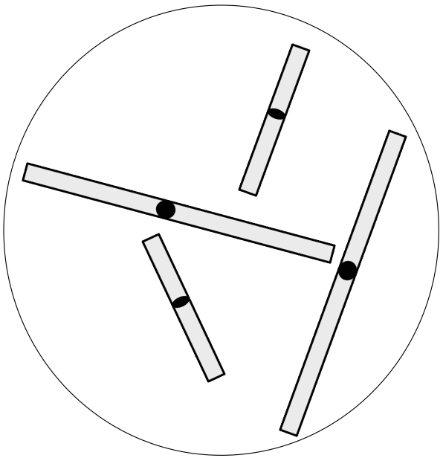

a) b) c)
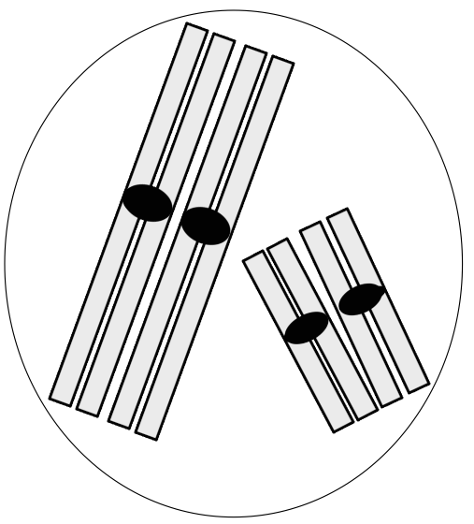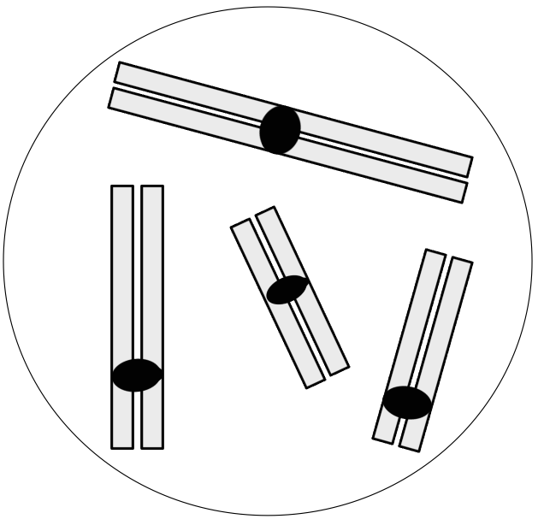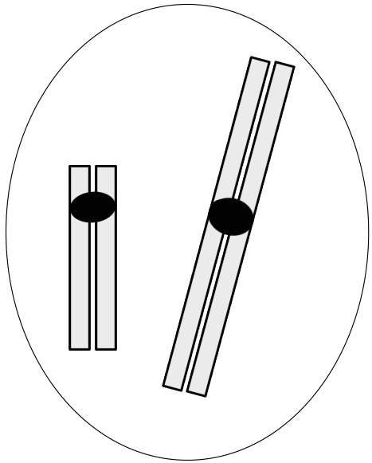

Expert answer: c

Alternatives/misconceptions: a) i) [RARE] A tetrad/pair of homologs is comprised of two double stranded DNA molecules (that is, this is valid when the two homologs are paired, but not when they are unpaired).

a+b) i) Two sister chromatids are two DNA strands, so one DNA molecule.
ii) Each chromosome [composed of sister chromatids] is one double stranded DNA molecule.

b) i) Two sister chromatids are one DNA molecule, but this does not apply to chromosomes when they are paired.

Concept: representation of chromosomes, relationship between chromosomes and DNA molecules.
Bloom level: III
Difficulty index²: 0.23
D²: 0.35
D.E.²: 0.81
Common incorrect answers² none; low difficulty index question.

Question 11 [select all the answer the apply]

Which of the cells represented below contain a total of eight chromosomes?

a) b) c) d)
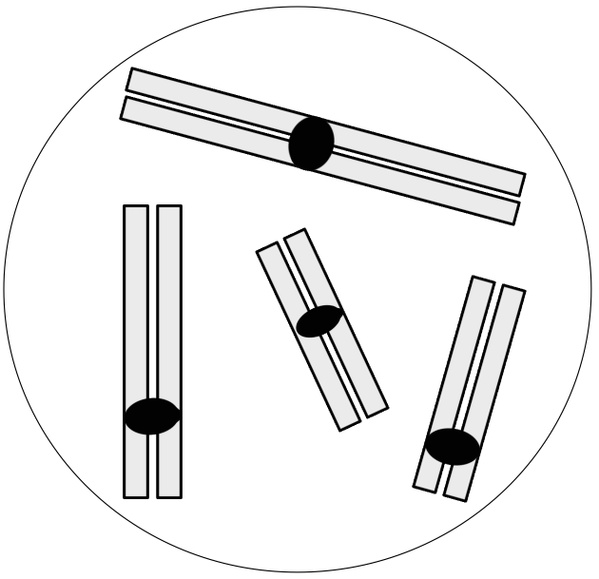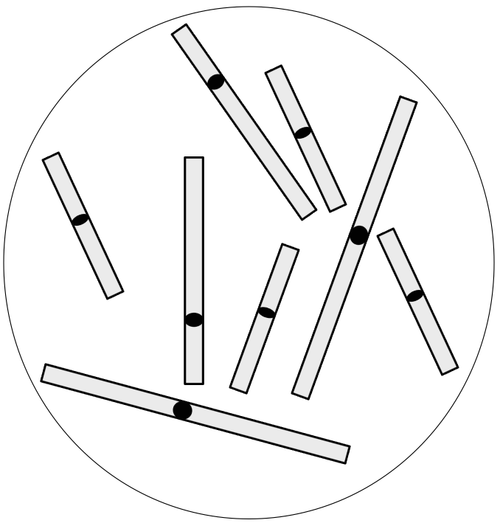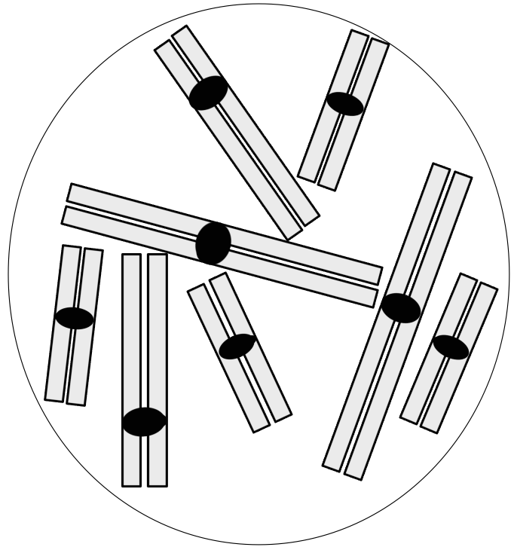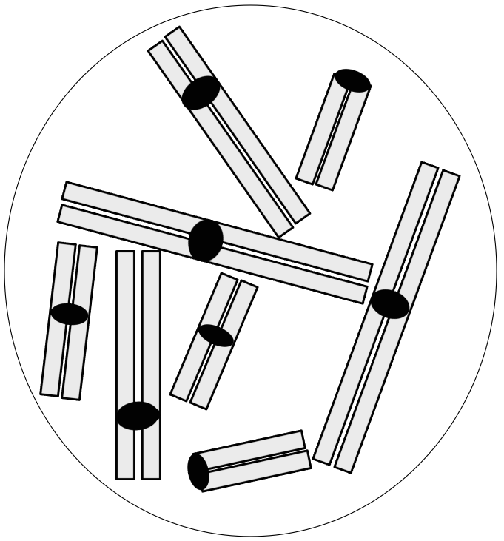

Expert answer: b+c+d

Alternatives/misconceptions: a+b) i) A “bar” [one DNA molecule] is a chromosome.

b+c) i) A chromosome is one unit that is physically separate from the others, it can have an “I” or an “X” shape (√); inteprets the diagrams of the two telocentric chromosomes as “broken” or “half“ chromosomes.

c) i) Idea that chromosomes have to be composed of two sister chromatids to be called “chromosomes”; inteprets the diagrams of the two telocentric chromosomes as “broken” or “half“ chromosomes.

c+d) i) Idea that chromosomes have to be composed of two sister chromatids to be called “chromosomes”.
Concept: representation of chromosomes, what “counts” as a chromosome.
Bloom level: III
Difficulty index²: 0.25
D²: 0.44
D.E.²: 0.79
Common incorrect answers² none; low difficulty index question.

Question 12 [select the best answer]

What is the total number of chromosomes in the cell represented below?
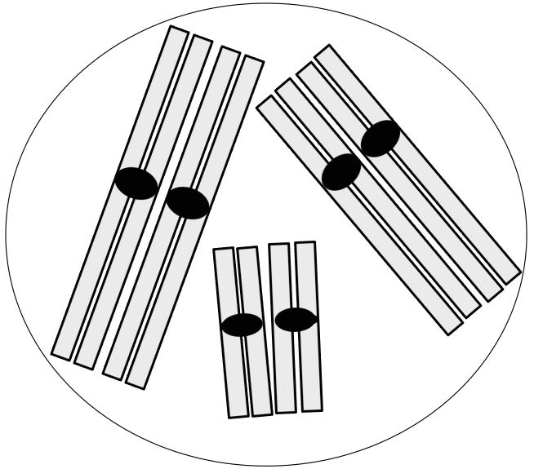
a) 2.

b) 3.

c) 6.

d) 12.

Expert answer: c

Alternatives/misconceptions: a) i) Confusion between number of chromosomes and number of sets of chromosomes.

b) i) Confusion between a tetrad/pair of homologs and a chromosome.
ii) Idea that the “number of chromosomes” refers to the number of “kinds” of chromosomes (haploid number).

d) i) Confusion between a chromosome and a chromatid.

Concept: what “counts” as a chromosome, representations of chromosomes.
Bloom level: III
Difficulty index²: 0.09
D²: 0.21
D.E.²: 1
Common incorrect answers² none; very low difficulty index question.

Question 13 [select the best answer]

The amount of DNA in a woman’s skin cell prior to DNA replication is the same as the amount of DNA in one of her

- germ cells at metaphase of meiosis I.
- germ cells at prophase of meiosis I.
- germ cells that have completed meiosis I, but have not yet started meiosis II.
- mature gametes (germ cells that have completed meiosis II).

Expert answer: c

Alternatives/misconceptions: a) i) At metaphase the cell splits into two identical cells.

b) i) Chromosomes double between prophase and metaphase of MI.
ii) DNA replication happens during prophase/at the start of meiosis.

d) i) Gametes and somatic cells have the same amount of DNA, even though the ploidy level is different.

Concept: changes in the amount of DNA in a cell in relation to timing of events in meiosis.
Bloom level: III
Difficulty index²: 0.53
D²: 0.38
D.E.²: 0.42
Common incorrect answers² b (31%)³.

Question 14 [select all the answers that apply]

Which of the following events occur during prophase of meiosis I?

- Crossing over of homologous chromosomes.
- Lining up of homologous chromosomes in the centre of the cell.
- Pairing of homologous chromosomes.
- Replication of most of the chromosomal DNA (formation of sister chromatids).

Expert answer: a+c

Alternatives/misconceptions: a) i) Recalls that crossover happens in prophase I
ii) Idea that there is one important event per phase only.

b) i) Confusion between metaphase and prophase (terminology).

b+c) i) Pairing of homologs occurs because (and while) the homologs line up on the metaphase plate.

c) i) Recalls that pairing up happens in prophase, lining up at metaphase, and DNA replication outside of meiosis. Not sure about crossing over.
ii) Recalls that pairing up happens in prophase, lining up at metaphase, and DNA replication outside of meiosis; convinced that there is only one major event per phase.

d) i) [Alone or in combination]. Meiosis starts with DNA replication, which happens in prophase. No idea that DNA replicates in interphase.

Concept: timing of events in the cell cycle and meiosis in relation to chromosomes/chromatids.
Bloom level: I
Difficulty index²: 0.71
D²: 0.62
D.E.²: 1
Common incorrect answers² “a” alone (16%)³, and 33%³ of the answers included “d” (note: in first year, some of us consider “c” alone to be OK if crossovers have not been covered, even though incomplete and therefore scored as incorrect).

Question 15 [select the best answer]

The diagram below most likely represents the chromosomes of a cell at anaphase of
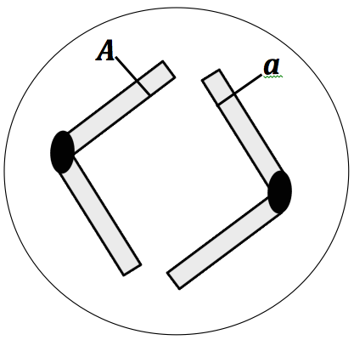
a) an impossible situation.

b) meiosis I.

c) meiosis II.

d) mitosis.

Expert answer: c

Alternatives/misconceptions: a) i) Sister chromatids are always identical (must carry the same alleles even at anaphase of meiosis I). [Students who have a good understanding of meiosis, but have not learned about crossing over, typically select this answer].

b) i) Sister chromatids* are different so it must be meiosis (√); sister chromatids* segregate at MI.
*Referred to as “chromosomes” or “chromosomes form a pair”.

d) i) Sister chromatids always carry different alleles in heterozygotes, and most cells do mitosis, not meiosis.
ii) [RARE]. The diagram shows evidence of crossing over (√), crossing over happens all the time in mitosis, but is rare in meiosis.

Concept: timing of events (segregation of sister chromatids); consequences of crossing over.
Bloom level: III
Difficulty index²: 0.30
D²: 0.57
D.E.²: 0.54
Common incorrect answers² none were very common, but 15%³ of the answers were “a”.

Question 16 [select the best answer]

The diagram below most likely represents the chromosomes of a cell at metaphase of

a) meiosis I.

b) meiosis II.

c) mitosis.

d) meiosis II or mitosis (impossible to tell which one).

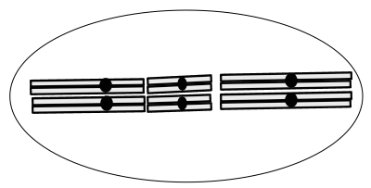

Expert answer: a

Alternatives/misconceptions: b) i) Homologous chromosomes pair up [in meiosis I] and then segregate at meiosis II.

c) i) Homologous chromosomes [but students don’t typically refer to them as such] appear paired-up at metaphase of mitosis.
d) i) Homologous chromosomes [but students don’t typically refer to them as such] appear paired-up at metaphase of mitosis as well as meiosis.

Concept: timing of events (segregation of sister chromatids); consequences of crossing over.
Bloom level: III
Difficulty index²: 0.22
D²: 0.33
D.E.²: 0.81
Common incorrect answers² none; low difficulty index.

Question 17 [select all the answers that apply]

Several cells like the one represented on the right undergo a normal meiosis I and meiosis II, so that each cell produces four daughter cells. One or more of these daughter cells are shown below. Which one(s) could they/could it be?
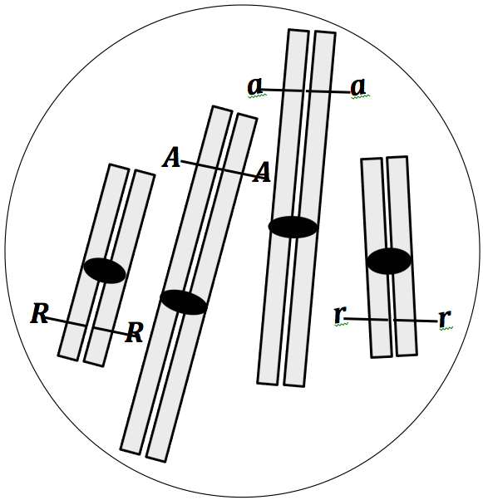

a) b) c) d)
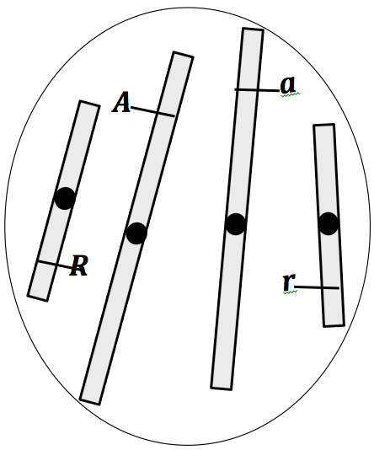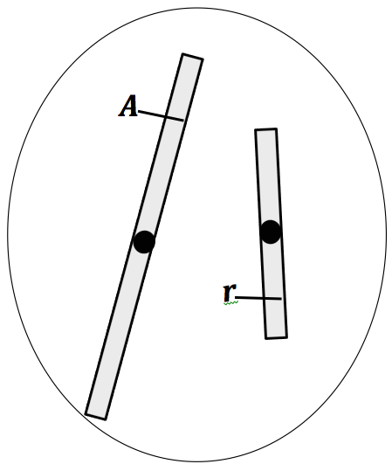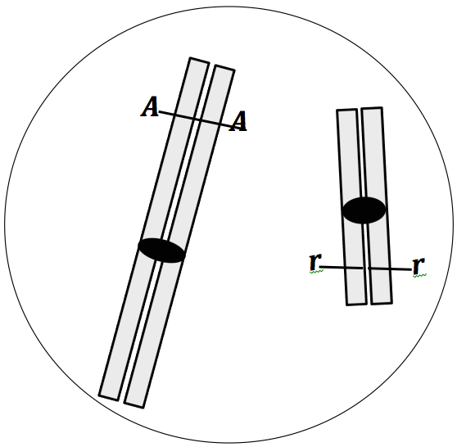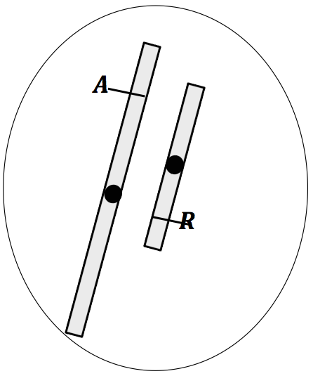

Expert answer: b+d

Alternatives/misconceptions: a) i) [alone or in combination with other options]. Confusion of meiosis and mitosis: idea that genetically, a gamete looks like a post-mitotic cell.

b) i) Idea that independent assortment ensures that the recessive allele of one gene will segregate with the dominant allele of the other gene.

c) i) [Alone or in combination with other options]. Idea that in a gamete, the chromosomes are still composed of sister chromatids.
ii) Idea that after any cell division all chromosomes are composed of sister chromatids.

d) i) Idea that “normally”, recessive alleles segregate together, and so do dominant alleles.

Concept: gamete formation, segregation of alleles and chromosomes.
Bloom level: III-IV
Difficulty index²: 0.39
D²: 0.60
D.E.²: 0.69
Common incorrect answers² “a” (29%)³.

Based on the answers of 193 1st year students when the item was used in a post-test. D.E.: discrimination efficiency. ² Compiled from 28 individual student interviews (validation interviews). ³ Percentage of students selecting this answer in our sample (N=193), who took the inventory as a post-test.

